**Module 2 Assignment: Modern JavaScript**

Jonathan Russial

IFT 458: Middleware Programming & Database Security

Dinesh Sthapit

5 February 2023

**Module 2 Assignment: Modern JavaScript**

Below are all of the screenshots taken during my completion of the second assignment for Module 2:

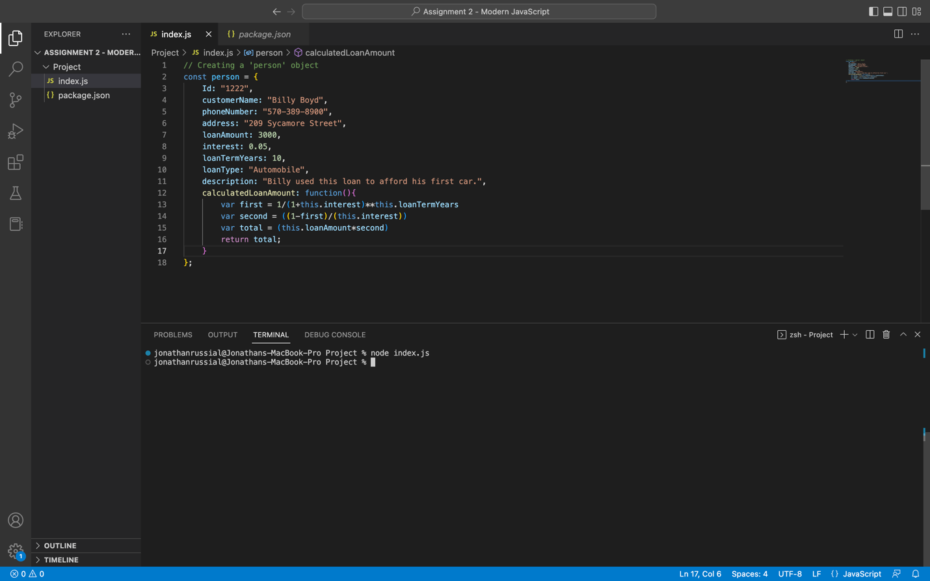

Below is the source code for ‘index.js’ file of this project:

// Creating a 'person' object

const person = {

Id: "1222",

customerName: "Billy Boyd",

phoneNumber: "570-389-8900",

address: "209 Sycamore Street",

loanAmount: 3000,

interest: 0.05,

loanTermYears: 10,

loanType: "Automobile",

description: "Billy used this loan to afford his first car.",

calculatedLoanAmount: function(){

var first = 1/(1+this.interest)**this.loanTermYears

var second = ((1-first)/(this.interest))

var total = (this.loanAmount*second)

return total.toFixed(2);

}

};

// Creating an array of 'person' objects

var persons = [

person2 = {

Id: "1223",

customerName: "Anna Kendrick",

phoneNumber: "572-301-7712",

address: "212 Maple Street",

loanAmount: 6000,

interest: 0.01,

loanTermYears: 10,

loanType: "Automobile",

description: "Anna used this loan to afford her first car.",

calculatedLoanAmount: function(){

var first = 1/(1+this.interest)**this.loanTermYears

var second = ((1-first)/(this.interest))

var total = (this.loanAmount*second)

return total.toFixed(2);

}

},

person3 = {

Id: "1224",

customerName: "Franklin Delgatto",

phoneNumber: "618-213-3116",

address: "33 Kinsley Boulevard",

loanAmount: 50000,

interest: 0.002,

loanTermYears: 15,

loanType: "House",

description: "Frank used this loan to afford his first house.",

calculatedLoanAmount: function(){

var first = 1/(1+this.interest)**this.loanTermYears

var second = ((1-first)/(this.interest))

var total = (this.loanAmount*second)

return total.toFixed(2);

}

},

person4 = {

Id: "1225",

customerName: "Zoey Gretsky",

phoneNumber: "573-299-0011",

address: "45 Carson Road",

loanAmount: 8000,

interest: 0.01,

loanTermYears: 25,

loanType: "Automobile",

description: "Zoey used this loan to afford her first car.",

calculatedLoanAmount: function(){

var first = 1/(1+this.interest)**this.loanTermYears

var second = ((1-first)/(this.interest))

var total = (this.loanAmount*second)

return total.toFixed(2);

}

},

person5 = {

Id: "1226",

customerName: "Samantha Nelson",

phoneNumber: "885-076-1290",

address: "880 Main Street",

loanAmount: 250000,

interest: 0.05,

loanTermYears: 15,

loanType: "Home",

description: "Sam used this loan to afford her first house.",

calculatedLoanAmount: function(){

var first = 1/(1+this.interest)**this.loanTermYears

var second = ((1-first)/(this.interest))

var total = (this.loanAmount*second)

return total.toFixed(2);

}

},

];

// Add our original 'person' object to the beginning of the 'persons' array

persons.unshift(person);

// Loop through array and display each customer and their calculated loan total

for (let i = 0; i < persons.length; i++) {

console.log(persons[i].customerName + ": " + persons[i].calculatedLoanAmount());

}

// Display the sum total of all five loans

console.log("\n");

var sumTotal = 0;

for (let i = 0; i < persons.length; i++) {

sumTotal += Number(persons[i].calculatedLoanAmount());

}

console.log("The sum of all five loans is " + sumTotal);